**1. Install Python and PostgreSQL**

* Ensure Python (3.8 or later) is installed on your system. You can download it from [Python's official website](https://www.python.org/downloads/).
* Install PostgreSQL from [PostgreSQL's official site](https://www.postgresql.org/download/). Make sure to note down the username (postgres by default), password, and database port (usually 5432).

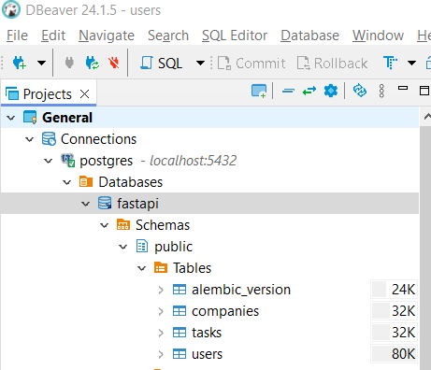

**2. Create a Virtual Environment**

Open your terminal or command prompt and navigate to project directory.

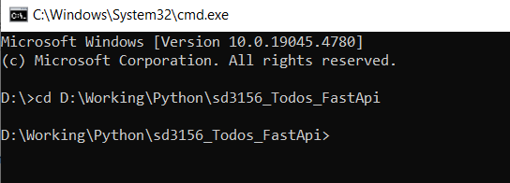

Create a virtual environment

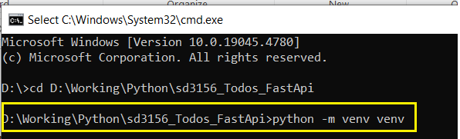

Activate the virtual environment

On Windows:

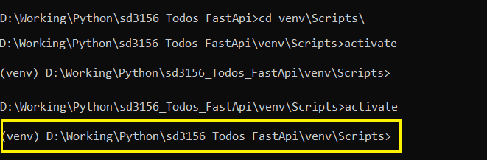

On macOS/Linux:

source venv/bin/activate

Install necessary packages:

pip install -r requirements.txt

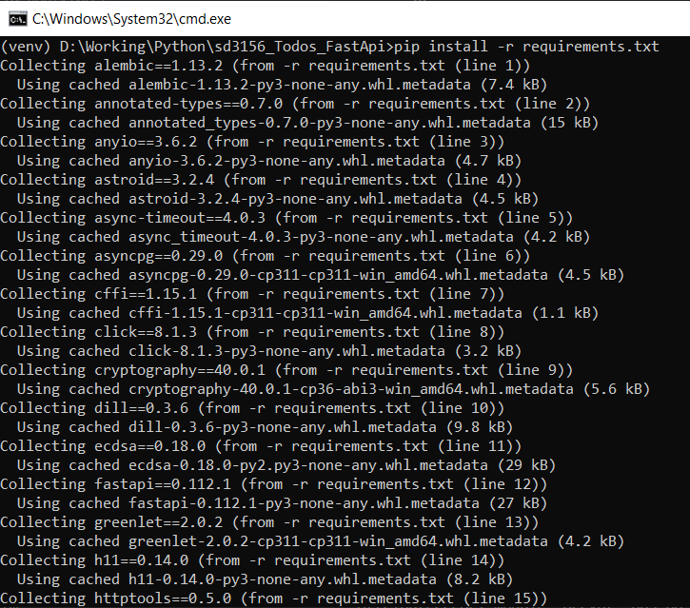

**3. Set Up PostgreSQL Database**

Create a new PostgreSQL database using DBEaver:

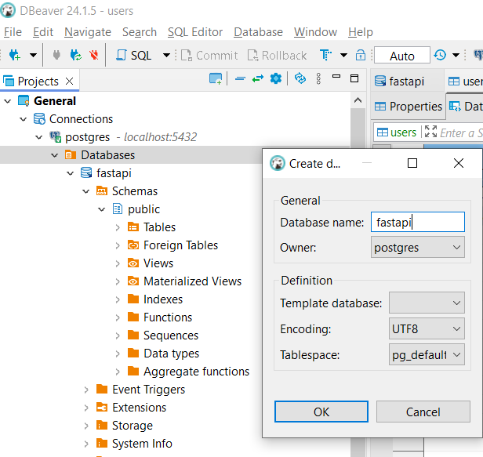

Configure .env file by creating a copy from .env.sample

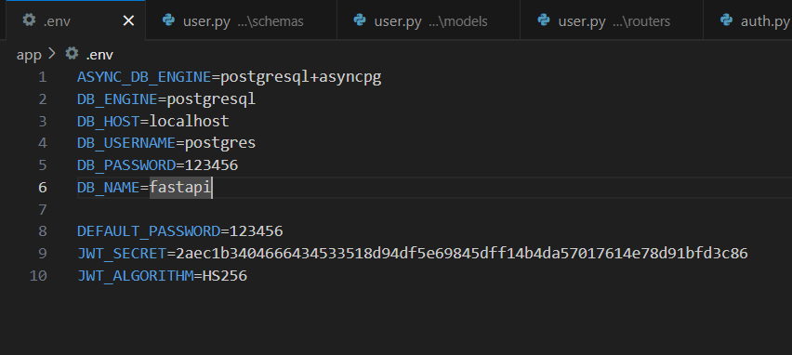

**4. Setting Up Alembic for Migrations**

Initialize and apply Alembic

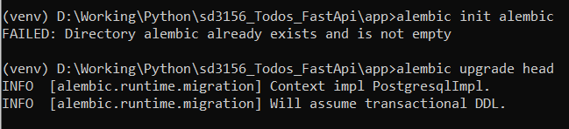

5. Running the FastAPI Application

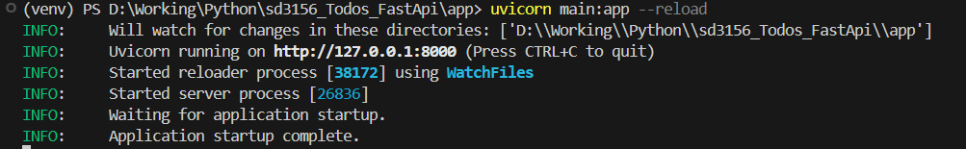

This will start the FastAPI application, and you can access it at http://localhost:8000/docs

